

M3508 Brushless DC Motor
M3508 直流无刷电机
User Guide使用说明
v1.0 2025.10

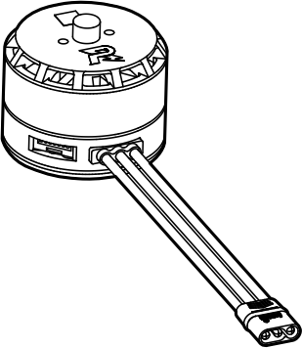



Contents
Disclaimer 2
Introduction 2
In the Box 2
Using the Product 2
Connecting to the MSC 2
Installation 3
Precautions 3
Performance and Parameters 4
Payload Characteristic Curves 4
Characteristic Parameters 5
Output Gear Parameters 5

目录
免责声明 6
简介 6
物品清单 6
产品使用 6
连接电调 6
安装 7
注意事项 7
性能与参数 8
负载特性曲线 8
特征参数 9
输出齿参数 9

Disclaimer
By using this product, you signify that you have read, understand, and accept the terms and conditions of this guideline and all instructions at https://www.robomaster.com. THE PRODUCT AND ALL MATERIALS AND CONTENT AVAILABLE THROUGH THE PRODUCT ARE PROVIDED "AS IS" AND ON AN "AS AVAILABLE" BASIS WITHOUT WARRANTY OR CONDITION OF ANY KIND.

Introduction
RoboMaster M3508 Brushless DC Motor (hereinafter referred to as the "motor") is designed for high-performance robots. When working with RoboMaster C620 Brushless DC Motor Speed Controller (hereinafter referred to as the "MSC"; the MSC is sold separately), it supports sinusoidal (sine-wave) drive, which provides higher efficiency, better dynamic performance, and greater stability than traditional square-wave drive.

In the Box
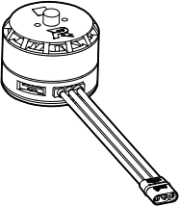
Motor × 1
7-Pin Data Cable
× 1

Using the Product

Connecting to the MSC
1. Use the included 7-pin data cable to connect the 7-pin ports on the MSC and the motor.
2. Connect the three-phase cable connectors of the MSC and the motor, ensuring that the wire colors match. DO NOT insert the connectors in the wrong direction.
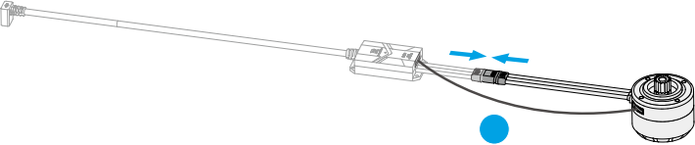

2

Installation
Refer to the following dimensions to select the mounting holes and install the motor based on your needs.

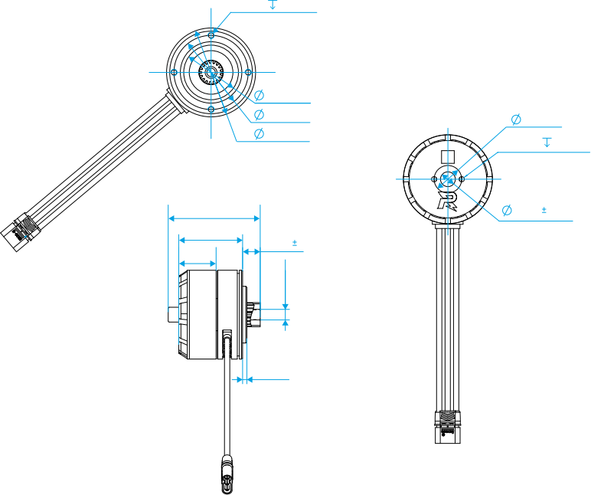
-0.025
5.00 -0.035
13.00
2-M3 4 EQS

7.00 0.02
4-M3 Unit: mm
43.40
30.10 17.60
0
26.8 -0.06
35.00 42.00
4 EQS
8.30 1
2.00

Precautions

• The motor has M3 threaded holes with a depth of 4 mm. DO NOT use excessively long screws. Otherwise, the printed circuit board (PCB) may be damaged.
• Make sure that the motor is securely installed.
• Use the motor under the maximum winding temperature. Prolonged overheating can permanently damage the motor.
• Avoid damage to the cables and wires. Otherwise, the motor may work improperly.
• DO NOT touch the rotors to avoid injury.
• DO NOT allow any foreign materials to come into contact with the rotors, as this may affect performance.
• The motor will heat during high-power operation. Avoid direct contact to prevent burns.

Performance and Parameters

Payload Characteristic Curves
Closed-Loop Speed Control Using C620 MSC
0.05 0.10 0.15 0.20 0.25 0.30 0.35
T (N·m)
η
n I
P
n (rpm)
8000
7000
6000
5000
4000
3000
2000
1000
0
η (%)
80
70
60
50
40
30
20
10
0
0
P (W)
400
350
300
250
200
150
100
50
0
I (A)
16
14
12
10
8
6
4
2
0

Closed-Loop Current Control Using C620 MSC
n
I η
P
0 0.05 0.10 0.15 0.20 0.25 0.30 0.35
T (N·m)
n (rpm)
9000
8000
7000
6000
5000
4000
3000
2000
1000
0
P (W)
450
400
350
300
250
200
150
100
50
0
η (%)
90
80
70
60
50
40
30
20
10
0
I (A)
18
16
14
12
10
8
6
4
2
0
Operating Range Diagram
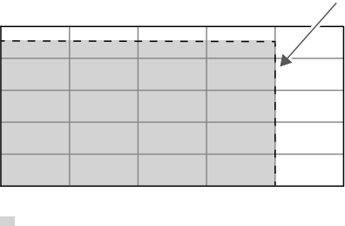
n (rpm)
10000
8000
6000
4000
2000

0
0.04 0.08 0.12 Continuous Operating Range
0.16
T (N·m)
125° C (257° F)

n-Rotational Speed, η-Efficiency, I-Current, P-Output Power, T-Torque
The above data were measured under laboratory conditions at an input voltage of 24 V, an ambient temperature of 25 °C (77 °F), and under normal cooling. They are provided for reference only. Adjust the motor running time based on the actual conditions such as operating temperature and cooling conditions.

Characteristic Parameters

Motor
Rated Voltage
24 V
0.02 N·m/A
390 rpm/V
260 rpm/N·m
49 ms
0.194 Ω
0.097 mH
0° to 50° C (32° to 122° F) 125° C (257° F)
7
276 N
120 g

9400 rpm 0.6 A
9085 rpm 0.16 N·m
Torque Constant
Rotational Speed Constant Speed-Torque Gradient
Mechanical Time Constant Phase Resistance
Phase Inductance
Operating Temperature
Maximum Winding Temperature Number of Pole Pairs
Rated Dynamic Load Motor Weight
Motor and C620 MSC at Rated Voltage*
No-Load Speed
No-Load Current
Rated Rotational Speed
Rated Torque (Maximum Continuous Torque)
Rated Current
10 A
83%
0.33 N·m
Maximum Efficiency Peak Torque
Peak Current 2.5 A
* All data in this table were measured under laboratory conditions. All current values represent the input current of the MSC, and the efficiency refers to the overall efficiency of the motor-MSC drive system.

Output Gear Parameters
Number of Teeth | 17
Module | 0.6
Pressure Angle | 20°
Pitch Diameter | 10.2
Addendum Diameter | 11.38
Dedendum Diameter | 8.68
Profile Shift Coefficient | -0.01
Tooth Span | 2
Common Normal | 2.79-0.04  -0.02

免责声明
使用本产品前，请您仔细阅读本文、访问 https://www.robomaster.com 阅读本产品相关的所有指引。使用本产品视为您已经阅读并接受本文与本产品相关的全部条款。

简介
RoboMaster M3508 直流无刷电机（以下简称为“电机”） 专为高性能机器人设计，搭配RoboMaster C620 无刷电机调速器（以下简称为“电调”，电调需另外购买）可以实现正弦驱动，相比传统方波驱动具有更高的效率、机动性和稳定性。

物品清单
电机 × 1 7-Pin 数据线 × 1
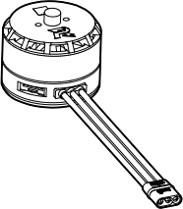

产品使用

连接电调
1. 使用包装内的 7-Pin 数据线连接电调和电机的 7-Pin 数据端口。
2. 连接电机的三相输入接头与电调的三相动力线接头，确保相同颜色的线对应连接。请勿强行反插接头。
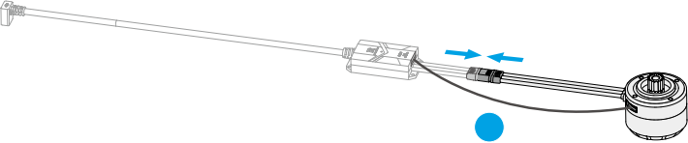

2

安装
参考以下尺寸，按需选择孔位进行安装。
4-M34 EQS
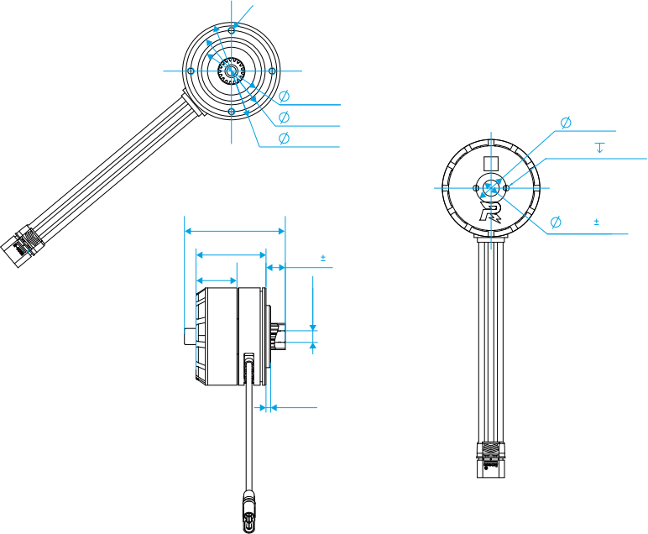
-0.025
5.00 -0.035
13.00
2-M3 4 EQS

7.00 0.02
43.40
30.10 17.60
0
26.8 -0.06
35.00 42.00
单位：mm
8.30 1
2.00

注意事项
• 电机安装孔为 M3 螺纹孔，深度 4mm，请勿使用过长的螺丝，否则可能会顶到电机的PCB 板从而损坏电机。
• 确保电机安装稳固。
• 请在绕组最大允许温度范围内使用电机，避免长时间过热而损坏电机。
• 请避免损伤线材，以防电机运行异常。
• 使用时请勿触摸电机转子部分，避免割伤。
• 避免杂物进入转子内部，以免导致转子运行异常。
• 电机大功率运行时表面温度较高，请勿直接触碰以免烫伤。

性能与参数

负载特性曲线
使用 C620 电调做速度闭环控制
η
n I
P
n (rpm)
8000
7000
6000
5000
4000
3000
2000
1000
0
η (%)
80
70
60
50
40
30
20
10
0
0
P (W)
400
350
300
250
200
150
100
50
0
I (A)
16
14
12
10
8
6
4
2
0
0.05 0.10 0.15 0.20 0.25 0.30 0.35
T (N·m)

使用 C620 电调做电流闭环控制
n
I η
P
0 0.05 0.10 0.15 0.20 0.25 0.30 0.35
T (N·m)
n (rpm)
9000
8000
7000
6000
5000
4000
3000
2000
1000
0
P (W)
450
400
350
300
250
200
150
100
50
0
η (%)
90
80
70
60
50
40
30
20
10
0
I (A)
18
16
14
12
10
8
6
4
2
0
工作范围图
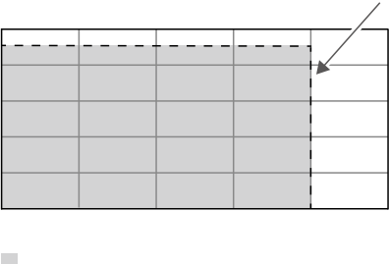
n (rpm)
10000
8000
6000
4000
2000

0
0.04
持续工作范围
0.16
T (N·m)
125°C
0.08
0.12

n-转速，η-效率，I-电流，P-输出功率，T-扭矩
以上数据均在输入电压 24V、25℃ 室温、正常散热的实验环境下测得， 仅供参考。实际使用时， 请根据工作环境温度、散热条件等实际情况来控制电机运行时间。

特征参数


电机  额定电压 | 24 V
转矩常数 | 0.02 N·m/A
转速常数 | 390 rpm/V
转速转矩梯度 | 260 rpm/N·m
机械时间常数 | 49 ms
相电阻 | 0.194 Ω
相电感 | 0.097 mH
使用环境温度 | 0℃至 50℃
绕组最高允许温度 | 125 ℃
极对数 | 7
额定动载荷 | 276 N
电机重量 | 120 g
电机搭配 C620 电调在额定电压下使用 *

空载转速 | 9400 rpm
空载电流 | 0.6 A
额定转速 | 9085 rpm
额定转矩（最大连续转矩） | 0.16 N·m
额定电流 | 10 A
最大效率 | 83%
峰转矩 | 0.33 N·m

峰转电流 2.5 A
* 本表格中的数据均在实验环境下测得。电流均为电调的输入端电流，效率为电机与电调组成的驱动系统整体效率。

输出齿参数  齿数 | 17
模数 | 0.6
压力角 | 20°
分度圆直径 | 10.2
齿顶圆直径 | 11.38
齿根圆直径 | 8.68
变位系数 | -0.01
跨齿数 | 2
公法线长度 | 2.79-0.04  -0.02



如果您对说明书有任何疑问或建议，请通过 DocSupport@dji.com 联系我们。
If you have any questions about this document, please contact DJI by sending a message to DocSupport@dji.com.
RoboMaster and ◎sonA5T are trademarks of DJI.
Copyright © 2025 DJI All Rights Reserved.
RoboMaster 和 T 是大疆创新的商标。
Copyright © 2025 大疆创新 版权所有

